Developer documentation

Group member: Junming Wu #1002338552

Jialing Wang #1002908302

Part1 General architecture of our application:

When you login into our website, we have a welcome page to ask you to login or signup for our website.

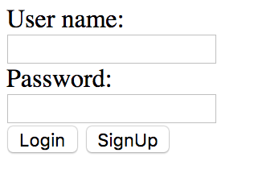

Then, after you login in, you can see a list of thumbnail images you upload before.

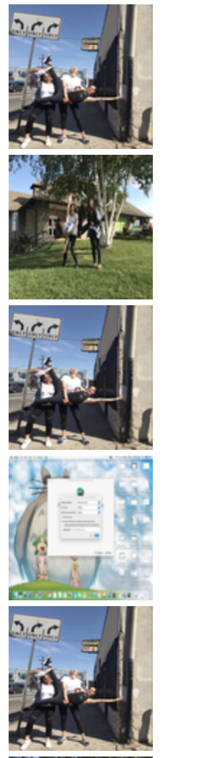

When you click on the thumbnail, you will be redirected to the image detail. Which shows you the original picture and its transformations.









At the bottom of the homepage, you can choose to upload a new picture.



We also provide a URL for test purpose. That’s <http://0.0.0.0:5000/test/FileUpload/Linda/Linda2Tom>

The last two filed are the username and password registered.



Part 2 Schema of our database:

We have two tables in our database。 One is called userimg, it’s to store the